Medieval Clout 2019 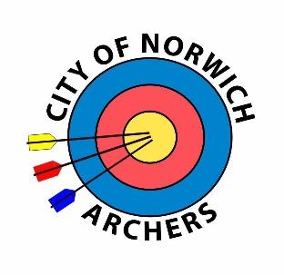

(5 doz arrows shot at Foam Knights and Castles,
followed by 5 fun Themed Targets.)

Sunday 11th August 2019

Venue: Hellesdon High School, Middletons Lane, Norwich, NR6 5SB

Start Time: 11:00am

Distances: 130 / 100 / 80 yards

Awards: According to Entries

Fee: £8 Seniors £6 Juniors

Organiser: Mr Graham Harris, Clickers Archery Ltd, 63 Borrowdale Drive, Norwich, NR1 4NS

Email: accounts@clickersarchery.co.uk

Entries and payment to be received by Saturday 3rd August.

No compound bows with a Peak draw weight of more than 30 lb may be used.

Tea Coffee and cold drinks available all day.

Payment can be made via BACS to:
City of Norwich Archers 30-96-17 8299 6460

Club: Contact Email:
Name | AGB No. | M/F | Sen/Jnr | Bowstyle | Distance | Fee
 |  |  |  |  |  | £
 |  |  |  |  |  | £
 |  |  |  |  |  | £

I agree for information given on this form to be used for running this event and used for the publication of target lists and results

Please Tick Signature of Parent/Guardian for junior entrants

